

**MARKING GUIDE**

**P615/4**

**CRAFT B**

**Art Studio Technology**

1. (a) Explain the meaning of 3D art work. (02 marks)

*SD art work is the kind of art work d one using solid material. And can be viewed all around from different directions or angles.*

(b) Explain atleast five elements that are identifiable only on 3D art works. (05 marks)

*The elements that are only identifiable on 3D artworks include*

1. *Form / shapes*
2. *Contours*
3. *Solids*
4. *Planse*
5. *Spaces*
6. *Volume*
7. *Texture*
8. *Tone*
9. *Pattens*
10. *Line*
11. *Colour*
12. *Voids*
13. ***Contours.***  *Are the implied / imaginary lines that suggest movements.*
14. ***Planes*** *are the different faces of the solid structure as viewed from the different directions.*
15. ***Solids.*** *Is the physical material used to make the 3D at structure*
16. ***Space*** *is the surrounding area around and over the physical solid material with in which it can be viewed.*
17. ***Volume***  *is the exact / total space that is required for the physical solid structure of art to occupy.*

1. (a) What is **paper mache**? (01 mark)

*Paper mache is the kind of art work done using paper pulp or pinched tiny pieces of paper that mixed with an adhesive like glue or cassava flour to make it sticky on continuous addition to form a sculpthre.*

(b) Explain how paper mache may be used to create a standing sculpture.

(07 marks)

*The steps taken to create a standing sculpture using paper mache*

1. *Make a desired sketch*
2. *Prepare an a mature in reference to the sketch provided with a pedestal base for stability.*
3. *Effectively lay wire mesh over the amarrture that will hold onto the pinched papers.*
4. *Soak papers / toilet papers and pinch them to their smallest size possible.*
5. *Effectively squeeze out water from the pinched soaked papers and place into an empty bucked.*
6. *Mix the pinched papers with an adhesive to evenly distribute either glue or boiled cassava flour in porridge state.*
7. *Pinch and add the mixture of paper and adhesive by pressing gradually to evenly cover all over the wire mesh to form a desired sculpture*
8. *Let the sculpture dry gradually under a shade to avoid any likely cracks due to uneven drying.*
9. *You can embellish or decorate the ready dried sculpture to your desired finish.*

1. (a) What is an **assemblage**? (01 mark)

*An assemblage is a sculptural art work comprised of a collection of parts that are attached and joined together these can be of the same material or mixed materials.*

(b) Mention some tools and material that can be used to form assemblages.

(10 marks)

***Tools Materials***

* *Hammers metals*
* *Pliers woods*
* *Saws iron sheets*
* *Screw drivers plastics*
* *Welding rods rivets*
* *Soldering machines screw nails*
* *Weld machines nails*

*Binding wires*

*Rubber bands*

*Solder*

1. Explain the importances of toning while executing an art work. (05 marks)

*Importance of toning while executing an art work include;*

1. *Helps to create form*
2. *It helps show differences in colours of structures being studied*
3. *It helps to show the directions of light*
4. *It helps express perspective effects or differences in distance*
5. *To express texture and patterns of surfaces under study*
6. *On lines they can express the rigidity and flexibility of material.*
7. (a) What is a pattern? (01 mark)

*A pattern is a repeated motif or design with consistency*

***OR***

*A pattern is a repeated element of design arranged consistently.*

(b) Which principles of art and design will the use of patterns satisfy?

(05 marks)

*The use of patterns majorly satisfy the following principles.*

1. *Rhythm*
2. *Harmony*
3. *Movement*
4. *Unity*

1. Demonstrate with the aid of relevant illustrations how you may decorate a cloth using block printing. (10 marks)

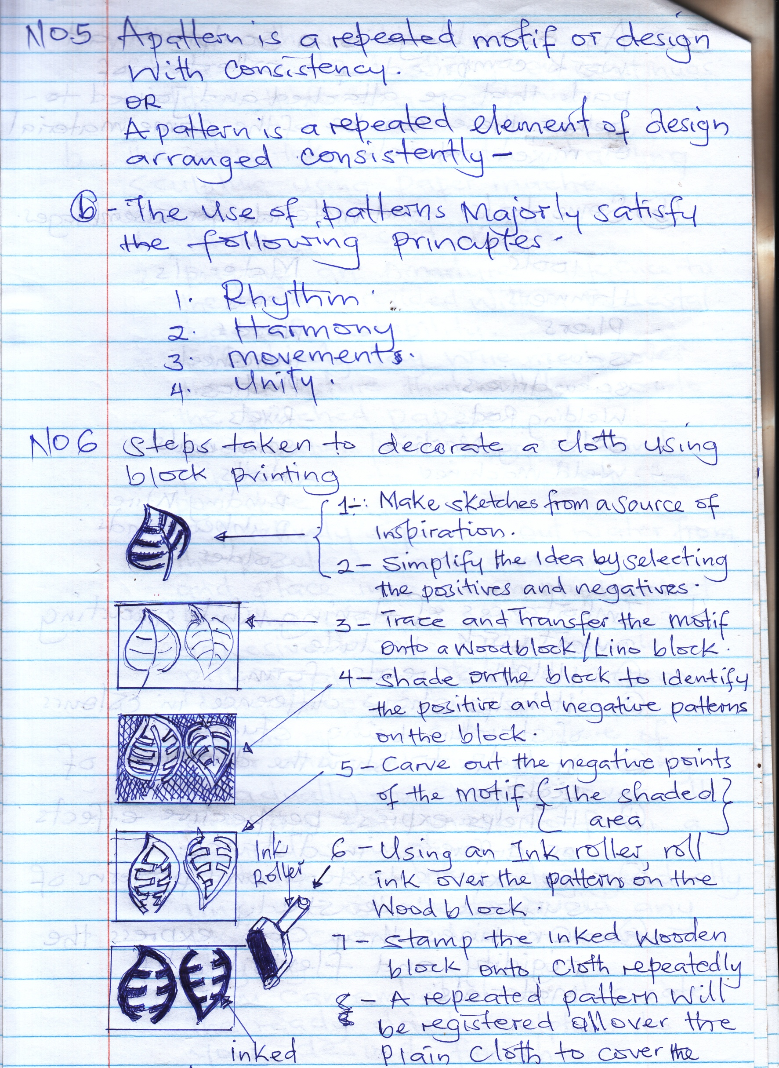

1. *Make sketches from a source of inspiration*
2. *Simplify the idea by selecting the positives and negatives*
3. *Trace and transfer the motif on to a wood block / lino block*
4. *Trace and transfer the motif on to a wood block / lino block*
5. *Carve out the negative points of the motif (The shaded area)*
6. *Using an ink roller, roll ink over the pattern on the wood block.*
7. *Stamp the inked wooden block onto cloth repeatedly*
8. *A repeated pattern will be registered all over the plain cloth to cover the whole*

*Inked*

*Motif on the block*

1. Explain the following terminologies as applied to clay: (05 marks)
2. Slip

*Slip is sieved liquid clay in a porridge state with out any particles*

1. Slaking

*Slaking is the process of soaking clay into a trough or bucket and stir it to turn liquid in preparation for the sieving process to form slip.*

1. Grog

*Grog is fine fired clay dust got after crushing and pounding a fired clay piece of work.*

1. Banishing

*Banishing is a process of directing or finishing leather hard clay vases by rubbing smooth metal surfaces over the vase to make smooth and glitterly.*

1. Terracotta

*Terracotta is the reddish brown colour attained after fitting clay vases or sculpture.*

1. What are the advantages of clay over wood in sculpture? (05 marks)

*The advantages of clay over wood in sculpture include.*

1. *Clay is soft and flexible to easily rectify mistake in the working process*
2. *Cheaper to get unlike hard wood*
3. *Clay can be recycled for multiple uses if not fired unlike wood*
4. *Clay surfaces are easily decorated using variety of techniques compared to rigid wood surfaces.*
5. *Fire clay can last for a test for a test of time compared to wood that may suffer insect attacks or rot from moisture.*
6. *It is easier to create hollow clay sculptures to manage weight unlike wood*
7. *Fired clay sculptures can effectively survive both outdoor and indoor condition unlike wood that survives best only in doors.*
8. (a) Explain the meaning of casting. (01mark)

*Casting is the process of pouring / adding liquid / molten / dump material into a prepared mold to form a 3D or relief salid work on solidifying.*

(b) How is casting used in daily life to form structures of purpose? (04 marks)

*Casting is utilized architectural finishes to create.*

1. *Concrete and steel bar beams and colomns*
2. *Create paving stones and slabs*
3. *Decorative balcony ball as trades*
4. *Road and garden kerbs*
5. *Drainage culverts*
6. *Ceramic toilet squatting pans*
7. *Making machinery parts*
8. *In glass industry to form products*
9. *Plastic industry to form products etc*

1. (a) What is leather work? (01 mark)

*Leather work is the art of using leather to create or form leather crafts using techniques such as shaping, colouring, sewing etc*

(b) Mention some tools and materials used to make leather crafts? (08 marks)

*Tools needed for leather crafts*

1. *Edge tools*
2. *Mallets / hammers*
3. *Punches oblong hole*
4. *Edge slickers / burnishes*
5. *Creasers / folder*
6. *Cutting boards*
7. *Gouges*
8. *Knives*
9. *Stamps*
10. *Punches round hole*
11. *Punches strap end*
12. *Setters / anvils*
13. *Sewing lacing awls*
14. *Sewing lacing chisels*
15. *Sewing machines etc*

***Materials***

1. *Leather*
2. *Glue*
3. *Thread*
4. *Leather dyes*
5. *Leather wax*
6. *Rivets / settlers*

**END**